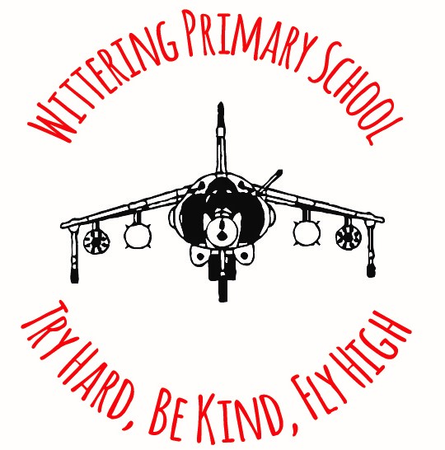

Home School Agreement

Wittering Primary School recognises that the successful development of its young people depends on an effective partnership of school, young people, parents/carers and staff. All parties share responsibility for the development, achievement, health and wellbeing of each pupil. Together, we commit ourselves to the following:
As a School we aim to:  - Provide a high standard of education and discipline  - Encourage strong links between home and school and to work in partnership with parents  - Develop a school ethos which is welcoming, conducive to learning in a stimulating way and provides a sense of community to all who are associated with the school  - Ensure a secure and caring environment where the children can feel safe, well cared for and happy while they learn and grow  - Treat everyone with respect. Be polite and courteous in all communications and maintain a professional relationship with parents/carers and all third parties  - Ensure that each pupil has the opportunities, support and guidance to achieve their full potential  - Recognise and celebrate each pupil’s individual needs and successes and report regularly on each pupil’s progress through Parents Evenings and an annual school report  - Keep parents/carers and appropriate third parties informed about school matters, be welcoming open and honest to enquiries and responsive to concerns  - Positively manage behaviour in a fair and consistent way, through proactive and reactive strategies of support, letting parents know about any concerns or problems that affect their child’s work or behaviour  - Monitor homework.  Signed ……………………….. Charlotte Blake Headteacher |  | As a Parent I aim to:  - Ensure my child attends school, arrives on time and is appropriately dressed and properly equipped and collect my child after school on time  - Encourage strong links between home and school and work in partnership with the school  - Attend meetings and discussions about my child upon request  - Support the school ethos by helping my children maintain school rules and contribute to the sense of community  - Comply with school policies which can be found on the website  - Make sure that time is not taken out of school unless prior consent has been given  - Communicate with school any issues which may affect my child’s learning  - Attend Parents’ Evenings and discussions about my child’s progress  - Support my child in home learning  - Keep Wittering Primary School informed about home matters, be welcoming, open and honest to enquiries and responsive to concerns  - Be polite and courteous in all communications to Wittering Primary School staff.  Signed …………………………… Parent/Carer  Name of Child …………………………….. Date ………………….

