WITTERING PRIMARY SCHOOL
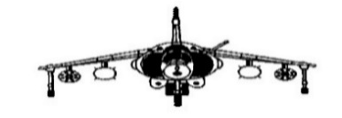
APPENDIX 3 – CALCULATIONS AND MASTERY
Develop fluency with basic number facts –
- Accurate and rapid recall of these basic number facts is critical for our pupils to have at their fingertips.
  - number bonds of numbers up to 10 which can then be used to find bonds to 20 etc. and
  - times-tables facts. Multiplication facts should be learnt in this order to provide opportunities to make connections e.g. use halving and doubling to work out other facts.
X 10 | X 5 | X 2 | X 4 | X 8 | X 3 | X 6 | X 9 | X 7

Develop understanding of the = symbol –
- Example missing number questions featuring the = sign are written into the Calculation Policy.
e.g. 3 + 4 = 6 +
- They need access to questions where the = sign is not always put at the end of the equation, as in the example above.
- Stress the fact that both/all sides of the equation should be the same, they should balance.
Use of balance scales and bricks to perform additions can reinforce this concept or an interactive site such Calculation Balance on the Topmarks website.
https://www.topmarks.co.uk/Flash.aspx?f=CalcBalancev5

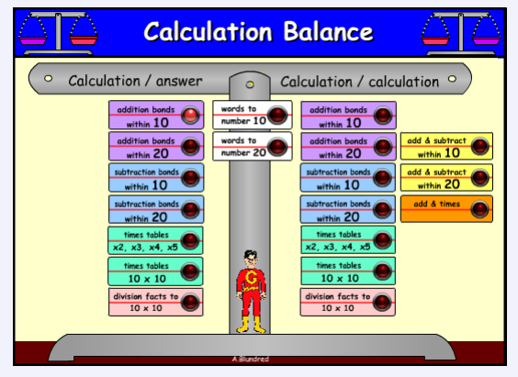

Teach inequality alongside equality –
- This starts in Year 1 where the children are introduced to the < and > signs.
- A useful model is one using rods and cubes to explain the less than and greater than concepts.
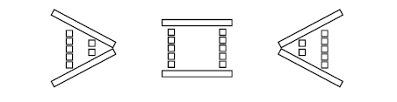
This shows that 5 is greater than 2; 5 is equal to 5; 2 is less than 5.
The interactive Calculation Balance on Topmarks would work well to show this concept as they have the inequalities displayed on the screen.

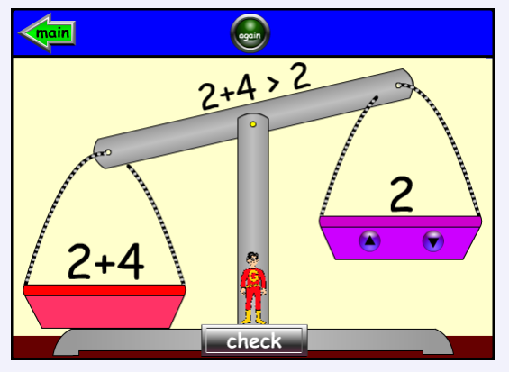

- Develop their reasoning skills by giving them missing symbol questions. E.g. 5 + 7 5 + 6.
- They could also have true or false questions e.g. saying whether 4 + 6 + 8 > 3 + 7 + 9.

Don’t count, calculate –
- EYFS and KS1 children should be encouraged to use counting on or clever counting to add e.g. 7 + 4. However, they should also be encouraged to use their number bonds to break down the above question. E.g. 7 + 3 = 10, so 7 + 4 must equal 11.

Look for patterns and make connections –
- ‘What’s the same, what’s different?’ should constantly be asked. E.g. ‘What’s the same and what’s different with the 3 times table and the 6 times table?’
- Think carefully about the written exercises we give children. They should be encouraged to reason and make connections between calculations, as in the missing number problems below.
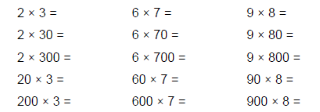
This is called ‘intelligent practice’ i.e. getting them to think and make connections.
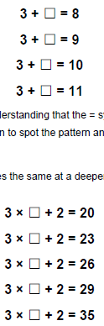
Further ‘intelligent practice’ exercises, where there is a missing number.

Missing operation exercises can also encourage reasoning skills, such as in the examples below.
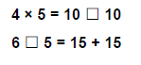
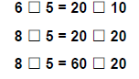

Using and comparing models to encourage systematic working –
- Starting in the EYFS and Year 1, children are encouraged to find pairs of numbers and to work systematically, when they do so. This might be done using a coat hanger and pegs to find all the pairs of e.g. 10.
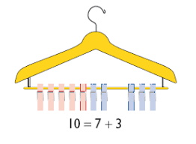
Part whole models and bar models can also be used to reinforce these basic number facts and to work systematically.
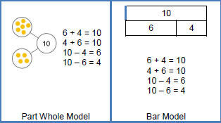
The question ‘What’s the same and what’s different?’ can be asked to encourage comparison and make connections.

Give them concrete, pictorial and abstract representations during lessons –
- Concepts are strengthened when they move between the concrete, pictorial and the abstract within a lesson. For example, in a lesson on adding fractions, they could be encouraged to draw the sum of ¼ + 1/8 = 3/8.
In another lesson they might be asked to say which picture represents the same question.
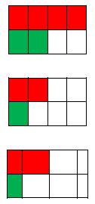

Putting the maths into a context – a word problem –
- Start the lesson with a word problem e.g. when you are teaching addition and subtraction.
As with any word problem, you should identify key numbers and words [that indicate which operation is needed]. A role play activity further emphasises the need for either addition and subtraction
When you get to the abstract question of 14 – 8, ask what the 14 means, the 8 means and why we are subtracting.
Keeping with the passengers on the bus scenario, ask what 7 + 7 could mean in that situation.
- They could be presented with pictures to show a ‘story’ or problem. The examples below show this.
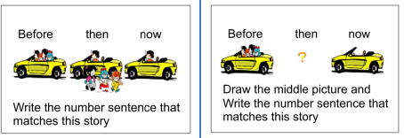
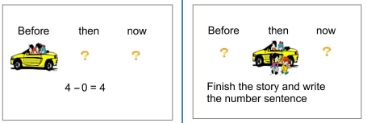

Questioning –
- Some of the following questions types are included in the Teaching for Mastery resources and the NCETM progressions for teaching reasoning skills – all included in the new Documents and Problem Solving and Reasoning folder.

- ‘What’s the same, what’s different?’
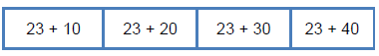
Here they should be encouraged to see the relationship between the calculations and use this to complete the rest of them.

- ‘Odd one out?’
This could be as simple as ‘Which is the odd one out of these numbers – 24, 15, 16 and 22?’ This is open-ended, encourages reasoning skills and prompts lots of discussion around number properties.
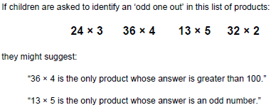

- ‘This is the answer? What was the question?’
  - This could be as simple as e.g. ‘The answer’s 100. What could the question be?’

  - When adding fractions, they could be presented with + = ¾

  - Another question might be.
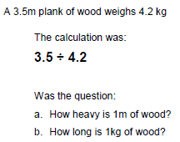

- True or false?
They could be given a set of calculations and they have to say whether they are true or false. They will be expected to reason about the relationships within the calculations rather than calculate.
- ‘What is the missing symbol?’

Expect correct mathematical vocabulary to be used and their answers expressed as full sentences –
- In every lesson they should have access to the relevant vocabulary either displayed on e.g. a working wall or on a word mat.
- They should be taught how to use the vocabulary through your modelling of its use. After you’ve modelled a full sentence, they should have the opportunity to repeatedly practise doing the same individually, possibly with a talk partner and ‘chanting’ sentences as a class. Key vocabulary can then be embedded along with the key concepts.
These full sentences might be –

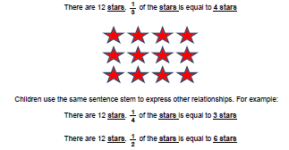
When talking about fractions, it is vital to make reference to the whole and the part of the whole in the same sentence. This can be seen in the above examples.

Identify difficult points –
- This is something we do as teachers - when planning ahead, anticipate what the tricky concepts might be and where they might meet pitfalls e.g.
- When you are working thorough an example, and make deliberate errors, they love pointing these out and this makes for some good discussion about how we correct questions and why the processes work in the way they do.

Paula Fox
MSL
June 2020

