WITTERING PRIMARY SCHOOL
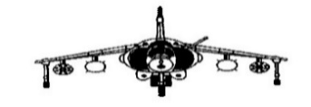
APPENDIX 1 – PROGRESSION IN USE OF MODELS AND IMAGES.
To maximize understanding and progress, we need a consistent approach to the use of models and images throughout the school. An image is a way of visualising something. A model is a way of representing a concept or a relationship or a way of demonstrating a strategy. A model involves something moving or changing. For example, a number line is an image and when you use it to count up [frog counting] from one number to another it becomes a model. A place value grid e.g. ITP Moving Digits is an effective image and when used to multiply numbers and move digits into different places it becomes a model.

The following is a progression of the use of models and images that we are going to adopt in our school.

The number line –
EYFS and KS1
- Starting in the EYFS they need access to pegged number lines [washing lines] to support counting, ordering and to show them how numbers are formed.

- They will also start making use of number tracks from 1-20. These will continue to be used by Year 1.
1 | 2 | 3 | 4 | 5 | 6 | 7 | 8 | 9 | 10 | 11 | 12 | 13 | 14 | 15 | 16 | 17 | 18 | 19 | 20

A number track is different to a number line in the way that the number occupies the space along the track.
A number line is continuous. The numbers are represented by points not spaces.
- Both 1-20 and 1-100 bead bars will start to be used by the EYFS and then throughout KS1 and into KS2.
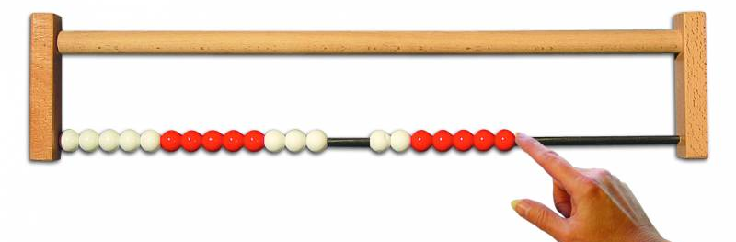
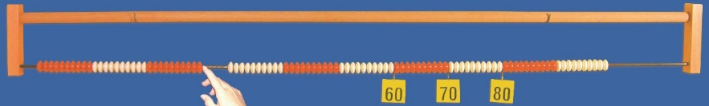
The children will handle bead strings. We have 1-10, 1-20, 1-50 and 1-100 bead strings in school. Again these will start to be used in the EYFS.
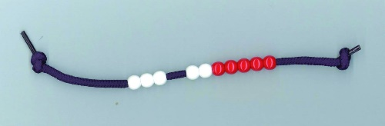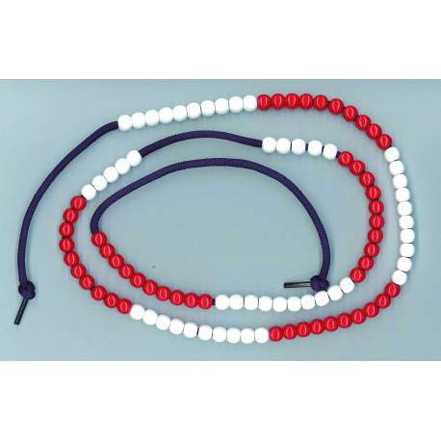

With both of these models, the children need to be shown that the ‘tag’ [label] is placed after the bead to indicate the number. Multiple of 10 tags might be added to the bead bar to help with identification of numbers. The beads are arranged in a repeating pattern of 10 red beads, and then 10 white beads, again to aid counting and identification of numbers.
This is a very useful image for teaching bridging e.g. 8 + 5.

- The beaded line is a pictorial representation of the bead string or bead bar. The children draw ‘tags’ after the beads on their lines. Again, the beads are arranged in a repeating pattern of 10 of one colour of beads and then 10 of another.

- The landmarked line – a line with some of the numbers marked on e.g. multiples of 10.

- The empty number line – a number line with only the numbers at the start and the end marked on e.g. 0 and 100. They might mark on 50 which is halfway across the number line. They need a well-developed mental image of the 0 to 100 number line to position numbers.

KS2
- Extend to using landmarked lines from 0 to 1000, with multiples of 100 marked on.
Lines with 0 to 1, with 0.1s labelled, where the children label numbers with 2 decimal places or lines with both positive and negative numbers.

Number grids –
1 | 2 | 3 | 4 | 5 | 6 | 7 | 8 | 9 | 10
11 | 12 | 13 | 14 | 15 | 16 | 17 | 18 | 19 | 20
21 | 22 | 23 | 24 | 25 | 26 | 27 | 28 | 29 | 30
31 | 32 | 33 | 34 | 35 | 36 | 37 | 38 | 39 | 40
41 | 42 | 43 | 44 | 45 | 46 | 47 | 48 | 49 | 50
51 | 52 | 53 | 54 | 55 | 56 | 57 | 58 | 59 | 60
61 | 62 | 63 | 64 | 65 | 66 | 67 | 68 | 69 | 70
71 | 72 | 73 | 74 | 75 | 76 | 77 | 78 | 79 | 80
81 | 82 | 83 | 84 | 85 | 86 | 87 | 88 | 89 | 90
91 | 92 | 93 | 94 | 95 | 96 | 97 | 98 | 99 | 100

EYFS
- 1 – 100 number grids can be introduced in the EYFS to count to 100 and to support number recognition.
KS1 and LKS2
- Children should have access to 1 – 100 number grids at all times in mathematics lessons.
- Spider counting using a 1-100 number grid is introduced. As the spider moves across a row, you add 1. As spider moves down a column, you add 10. The children can spot patterns and multiples [shown easily using the multiples tool on the ITP Number Grid] and it is extremely useful in developing place value knowledge skills.
- Cutting up a 1 – 100 track and arranging it into 10 rows will help them to see where the 1 – 100 number grid comes from.
Work out the missing numbers.
What steps is spider counting in on this grid?
What steps are you counting in as you move along the rows?
0.1 | 0.2 | 0.3 | 0.4 |  |  |  |  |  | 1
 |  |  | 3.4 | 3.5 | 3.6
 |  |  |  | 4.5
 |  |  |  | 5.5
 |  |  |  |  |  |  |  |  | 10

KS2
- These can be developed in later years with different number ranges e.g. a 10 to 1000 number grid or a 0.1 to 10 number grid [as seen above].
- The children could be given a partially completed grid which they have to complete – working out what steps spider is counting in now - how much is added as spider goes along each row and down each column.

Numicon –
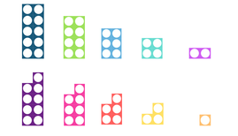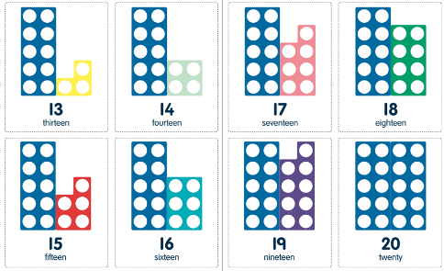
- This apparatus is used widely in the EYFS to help the children visualise and form a concept of numbers.
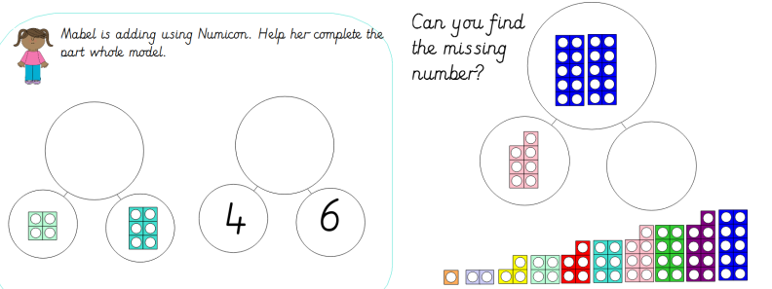
Here the numicon is used to complete part whole models.
- They are also very useful for KS1 when you are teaching the concept of odd and even numbers as the extra ‘odd’ one is clearly shown.

Place Value Grids –
Introduce in Year 3
- Although the place value grid is not essential until they meet decimals, it should be introduced in Year 3 when they are learning about multiplying whole numbers by 10 – seeing the digits move across the grid.
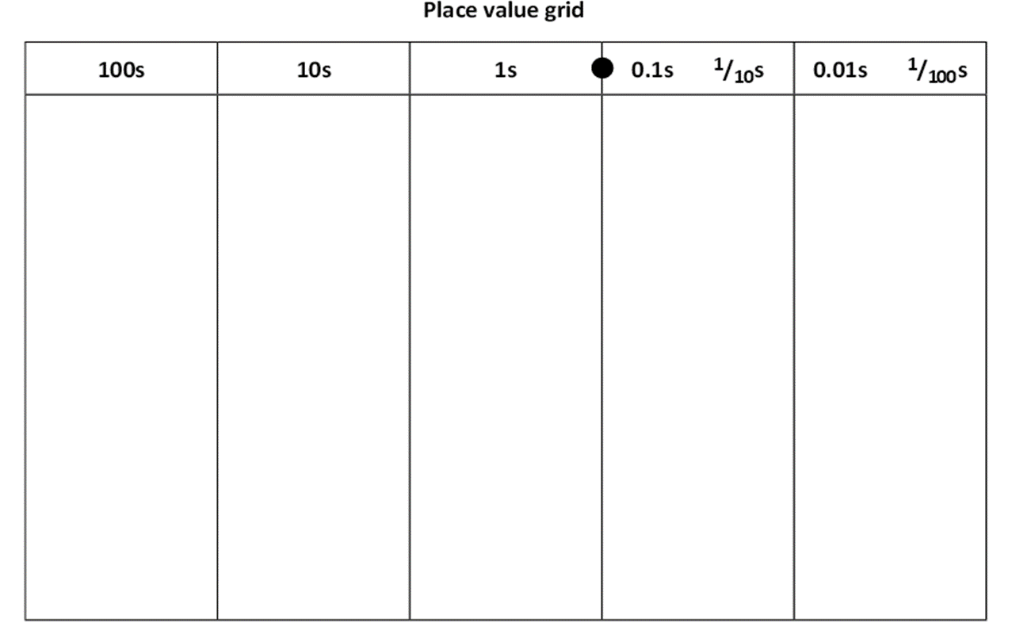
The ITP Moving Digits is excellent for illustrating the movement of the digits, when numbers are multiplied or divided by multiples of 10.

Place value cards –

Introduce in the EYFS
- They could have access to tens and ones cards to make and partition numbers up to 100.

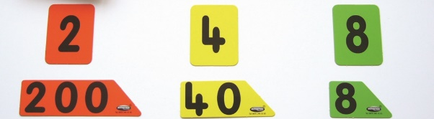
KS1
- Year 1 can continue to use cards to make 2-digit numbers and Year 2 can begin to make and partition 3-digit numbers.
KS2
- In LKS2 in particular, they can use place value cards to partition and to make up to 4-digit numbers.

The ITP Place Value can be used to partition and make numbers using place value ‘cards’ on the screen.

Multibase equipment or dienes –

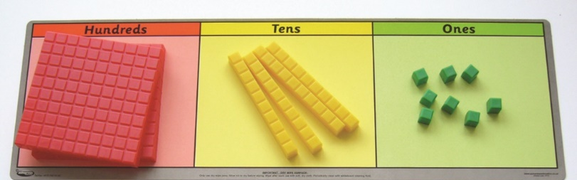

KS1
- As with place value cards, start making and partitioning 2-digit numbers. Children should have access to practical apparatus and then pictorial presentations of numbers.
- Year 2 can begin to make and partition 3-digit numbers using the apparatus. There are class sets of individual kits of the multibase equipment available in school.
KS2
- KS2 should continue to have access to multibase equipment to deepen their understanding and ability to visualise numbers over 3-digits.
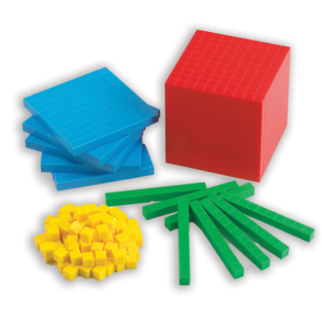
- This is particularly useful when teaching column addition and subtraction. The equipment can be placed on a place value grid to allow a more concrete understanding of the column method, leading to use where decomposition is needed i.e. exchanging.

Place value charts –

These can be introduced in Year 2 and then throughout the school.
- Year 2 could create 2 and 3-digit numbers using the chart. The children could place transparent counters onto columns on the chart to create numbers e.g. 100 + 20 + 5 = 125.
- They can be used throughout KS2 to create up to 7-digit numbers.
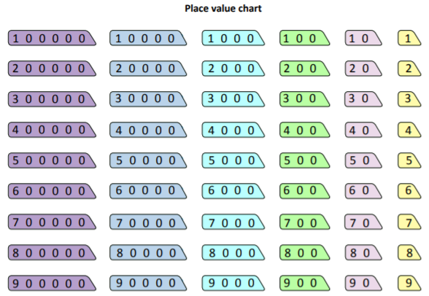

Abacuses and place value flip stands –

KS1 and KS2
- Abacuses [for numbers up to 6 digits, where stacked rings indicate the value of each digit] can be used to make different numbers.
- They are also effective for performing place value addition and subtraction questions
e.g. 125 – 20 = 105.

- In KS2 the abacus can be adapted to include decimal numbers by including a decimal point.

- Place value flip stands can be used to support their understanding of number, especially if used alongside an abacus.

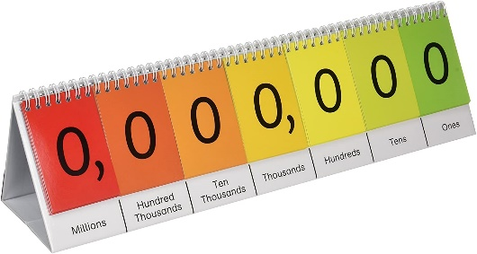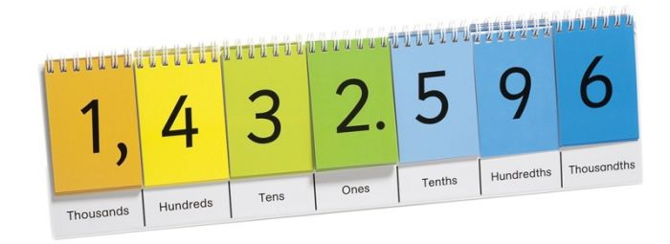

Part whole diagrams –

These should be started in the EYFS and continued up to Year 6.
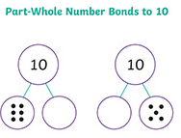
This is a part whole model where the whole is positioned at the top and the parts below.

- The children need to have access to other part whole diagrams as they go up the school – where the whole is positioned differently and there may be multiple parts.

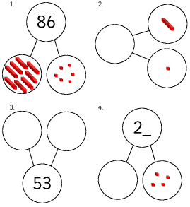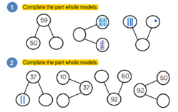

Bar models –

These should be started in the EYFS and continued up to Year 6.
- Refer to the recently produced [Spring 2020] Mathematics folders – documents and problem solving and reasoning resources for information on bar models. There is a progression for bar models as well as sample questions that a bar model would be appropriate for, contained in the folder.

- This is the simplest style of bar model. The parts are equal to the whole. This should be taught after lots of use of practical resources [concrete stage], then the use of pictures [pictorial stage] and finally the use of the abstract i.e. the bar model below. See Calculation policy for more information.
15 + ? = 20
20
15 | ?

- Subtraction word problems can be solved using bar models.
E.g. Lisa is using 48 beads for a necklace. She has 22 orange beads and 16 green beads. The rest are blue. How many blue beads does she have?

48
22 | 16 | ?

22 + 16 = 38 48 – 38 = 10
- Bar models are useful for seeing related addition and subtraction facts.
This can be started in the EYFS.
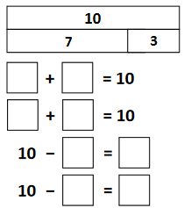
From Year 2 –
- Bar models can be used to help visualise problems involving finding fractions of amounts.
E.g. What is ⅔ of 15?
15
5 | 5 | 5

⅔ = 5 + 5
⅔ = 10

- They can be used to solve multiplication and division problems.
E.g. Together Boris and Donald have £1500. Donald has twice as much as Boris. How much does Boris have?

Boris
£1500
Donald

£1500 ÷ 3 = £500
Boris has £500.

E.g. The total of two numbers is 50. One number is 4 times bigger than the other. What is the bigger number?

10
10
10
10
10
50

50 ÷ 5 = 10
4 x 10 = 40.
The bigger number is 40.

- Bar models can be used for questions involving fractions, decimals and percentages.
E.g. A computer game was reduced by ⅕. It now costs £40. What was the original price?

£10 | £10 | £10 | £10 | £10

£40
To work out ⅕ £40 ÷ 4 = £10
To work out the original price i.e. 5/5 5 x £10 = £50.
The original price was £50.

Paula Fox
MSL
June 2020

